Project Initialization and Planning Phase

Date | 04 July 2026
Team ID | xxxxxx
Project Name | OptiCrop: Smart Agricultural Production  Optimization Engine
Maximum Marks | 3 Marks

Define Problem Statements (Customer Problem Statement Template):

Developed an intelligent crop recommendation system that analyzes soil nutrients (N, P, K), temperature,
humidity, pH, and rainfall using machine learning to recommend the most suitable crop, thereby improving agricultural productivity, resource efficiency, and sustainable farming practices.

Example:

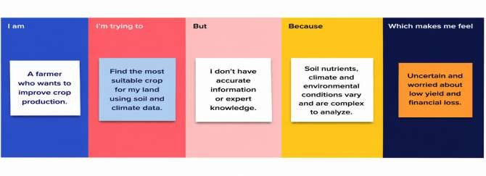

Problem Statement (PS) | I am (Customer) | I’m trying to | But | Because | Which makes me feel
PS-1 | A farmer | Select the best crop for my | I don't know which crop is  suitable for my | I have limited knowledge  about soil  nutrients and weatherimpact  on crops. | Confused and worried about crop yield.
 |  | land. | soil and climate
 |  |  | conditions.

PS-2 | An agricultural researcher | Analyze crop and  environmental data. | It is difficult to identify  patterns from large  agricultural  datasets. | Manual  analysis is time-consuming and complex. | Frustrated and less productive.
PS-3 | An agricultural policymaker | Develop  strategies to improve agricultural productivity. | I don't have  accurate data-driven insights for decision-making. | Crop  production depends on multiple  environmental  factors. | Concerned about making effective policies.

